**Amazon Clone Website**

Overview – This is an E-Commerce website clone of Amazon, in which I make Home page, Listing page, Product review Page & Check Out Page Similar to Amazon.

1. Home Page:

* Header
* 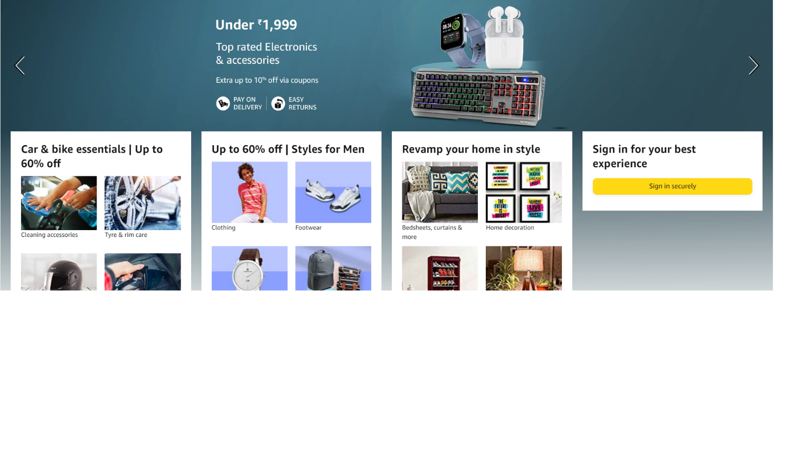Background (Like this):
* 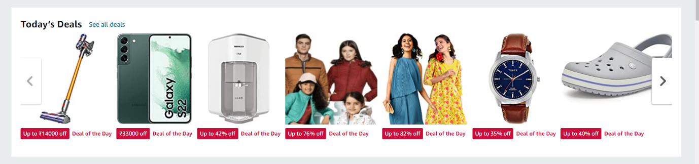Picture Row with sliding arrow (Like this):
* Picture Format (Like this):

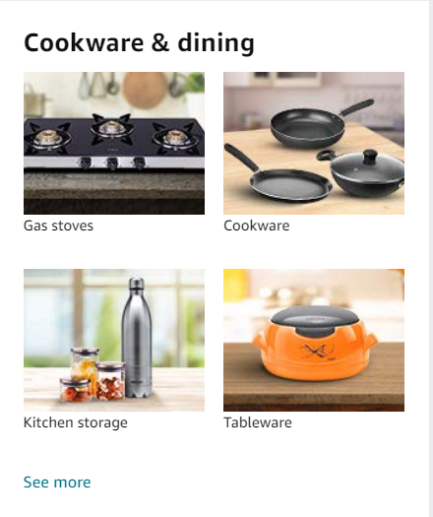

* 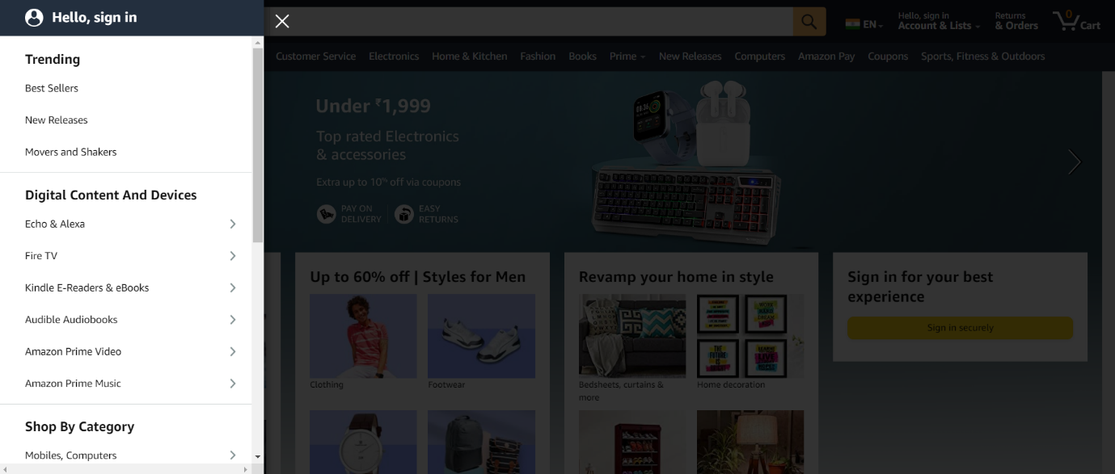Side List (Like this):
* 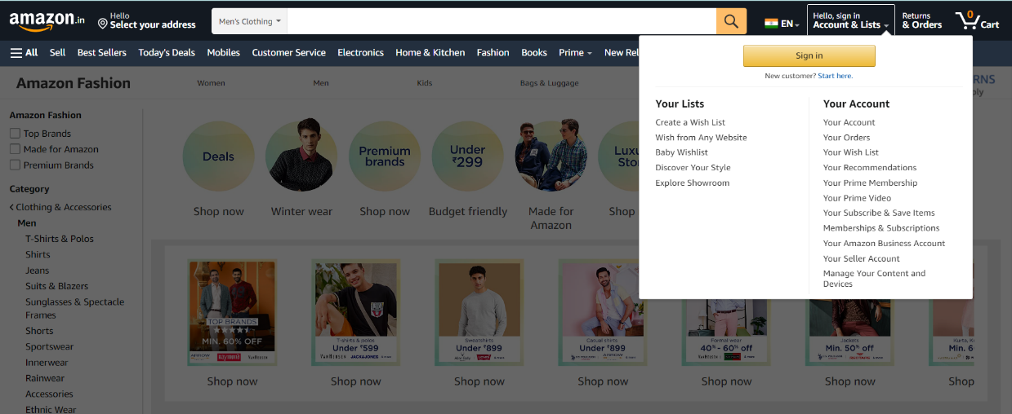Account & List (Like this):
* Footer:

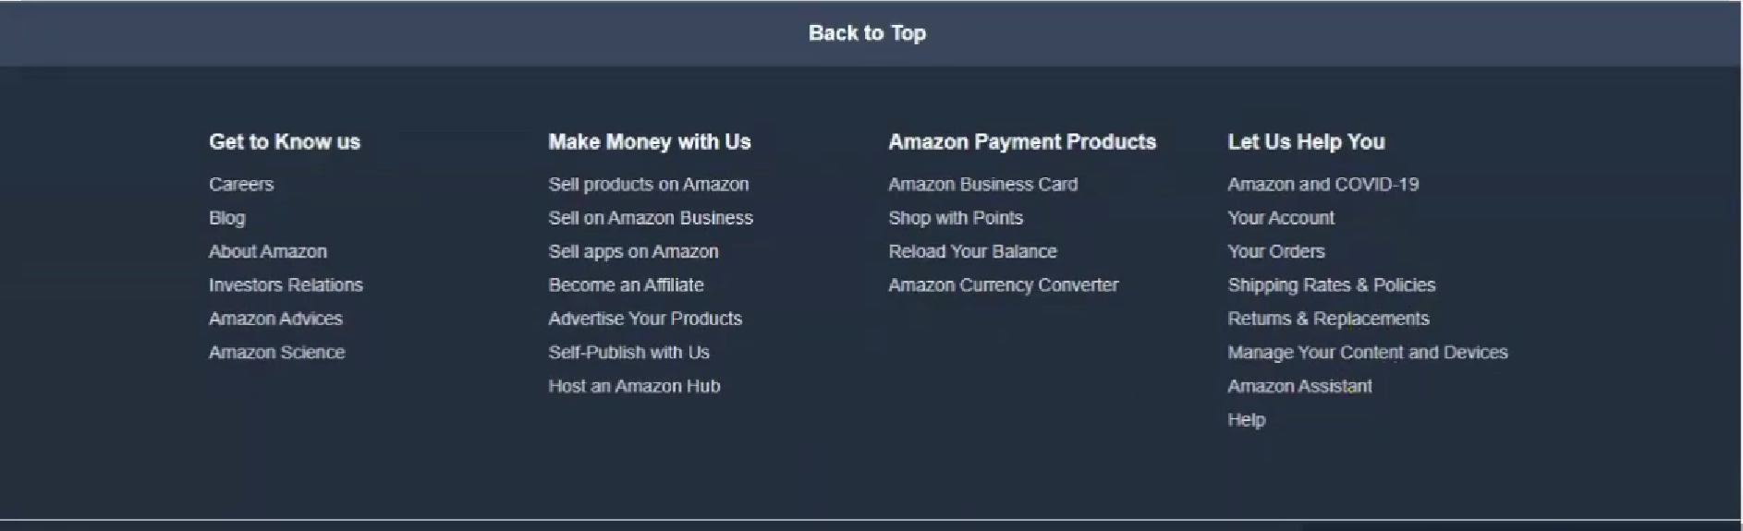

2. Listing Page:

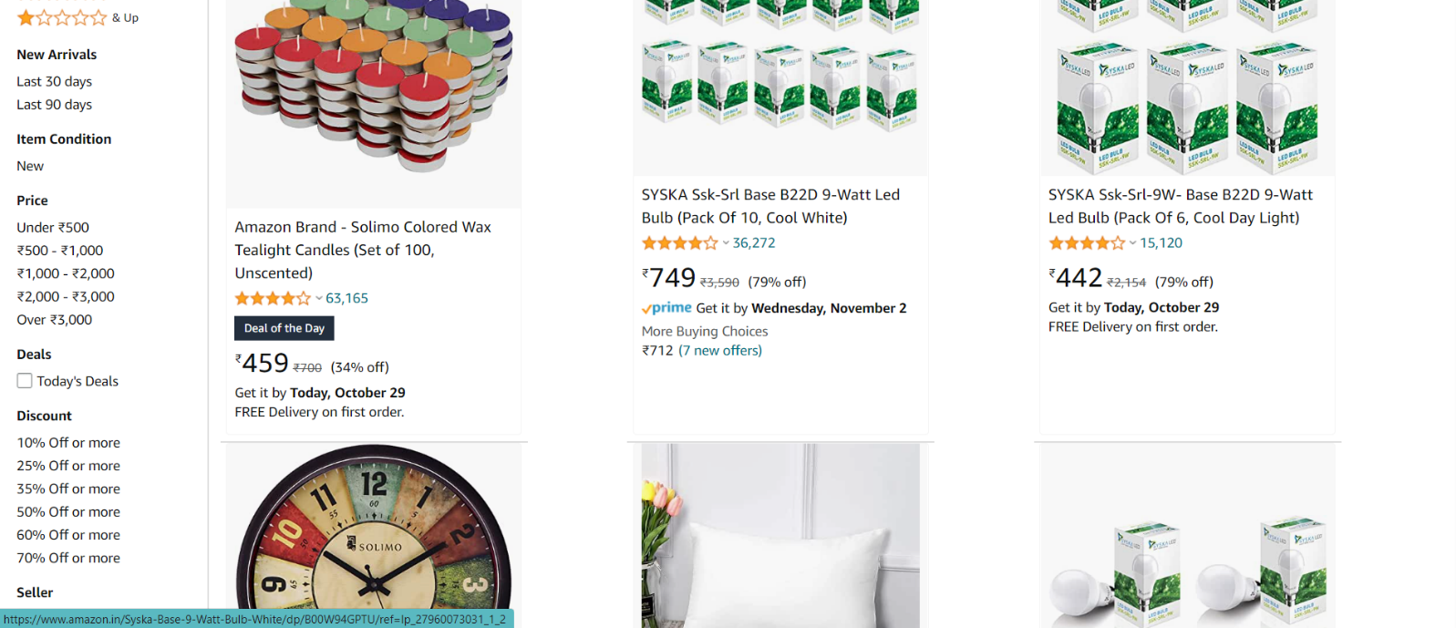

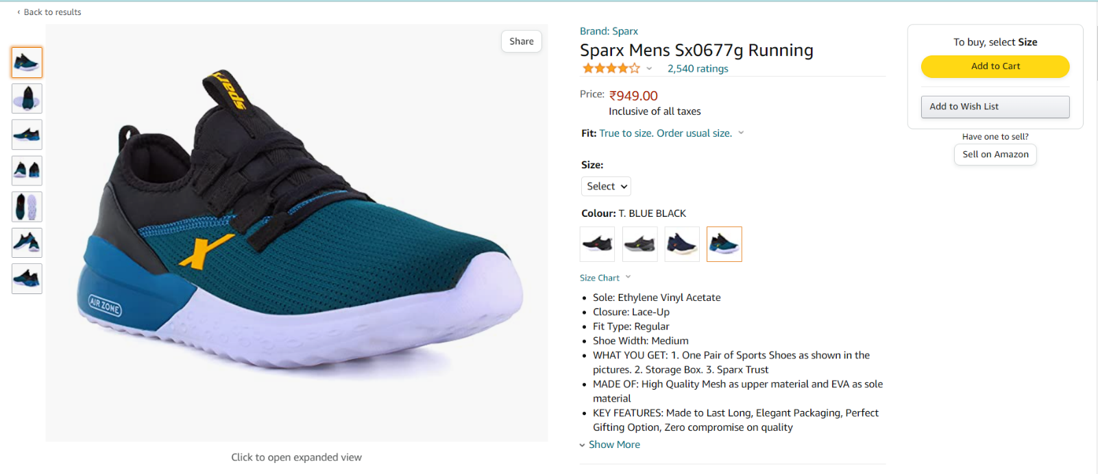3. Product review Page:

4. Check Out Page:

* 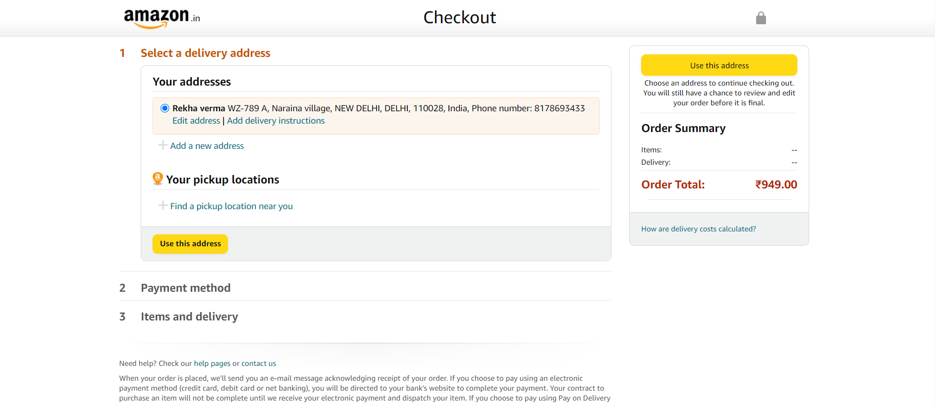Delivery Address:
* 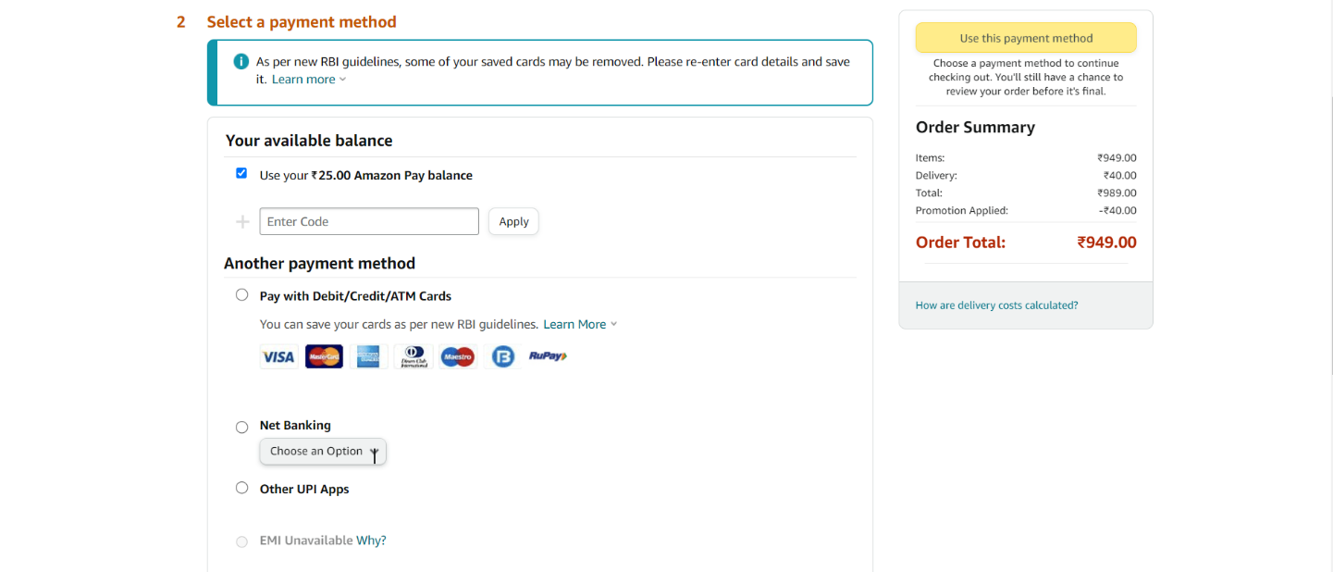Payment Method:
* 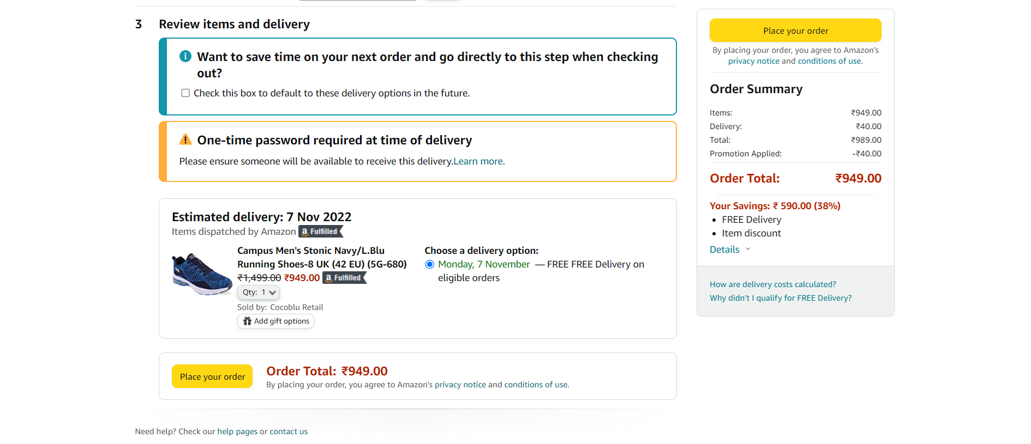Items & delivery: